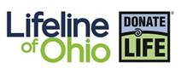**Donation & Transplantation Resources**

*The resources below provide valid representations of the organ donation and transplantation processes. As with any resource, teachers should preview these resources before use in the classroom. Feel free to contact your community educator with any questions you might have regarding content found in these resources.*

**Learning Can Be Lifesaving**

**Donate Life Ohio Classroom Video:**

[**https://m.youtube.com/watch?v=zeycu_hflK8&feature=youtu.be**](https://m.youtube.com/watch?v=zeycu_hflK8&feature=youtu.be)(13 min)

**Personal short stories from the Transplant Olympics:**

Second Chance Champions share their appreciation for the gift of life they’ve received. Others videos are offered on the same page to reach any audience. They are touching and good as an intro or closing. (1-3 min)

**Ryan’s story:**

[**https://m.youtube.com/watch?v=8SxmGlwSKXs**](https://m.youtube.com/watch?v=8SxmGlwSKXs)

**ESPN Konrad Reuland:**

The moving story of former NFL tight end, Konrad Reuland, who in his passing helped or saved the lives of 75 people, including baseball legend Rod Carew. **(8 min)**

[**https://m.youtube.com/watch?v=yVKtB20jTuc**](https://m.youtube.com/watch?v=yVKtB20jTuc)

**Legacy of Life**

This video tells the story of Ohio siblings, Erin (16) and Andrew (13). After a tragic car accident, the two gave the “gift of life,” saving the lives of numerous others. **(10 minutes)**

[**https://www.youtube.com/watch?v=lr4hxRRfUBY**](https://www.youtube.com/watch?v=lr4hxRRfUBY)

**LSU Auburn Connects Families**

This video tells the story of a young, 6 month old donor and how two families were united through his generosity. **(6 minutes)**

[**https://youtu.be/sXJrn2nM9Yg**](https://youtu.be/sXJrn2nM9Yg)

**How My Son’s Short Life Made a Lasting Difference**

After Sarah Gray's unborn son Thomas was diagnosed with anencephaly, a terminal condition, she decided to turn her family's tragedy into an extraordinary gift and donate his organs to scientific research. In this tribute to life and discovery, she shares her journey to find meaning in loss and spreads a message of hope for other grieving families.

[**https://www.ted.com/talks/sarah_gray_how_my_son_s_short_life_made_a_lasting_difference**](https://www.ted.com/talks/sarah_gray_how_my_son_s_short_life_made_a_lasting_difference)

**Ray of Hope**

This video is an ESPN E:60 segment. It tells the story of Jason Ray, the former mascot for the University of North Carolina Tarheels. It provides an overview of the donation and transplantation process. It also explains how and why Jason registered as a donor and emphasizes the importance of sharing your decision with your family. Viewers hear from Jason’s parents, as well as the four recipients of Jason’s organs and their families**. (15 minutes)**

[**https://www.youtube.com/watch?v=5rzkXwbL1Mg**](https://www.youtube.com/watch?v=5rzkXwbL1Mg)

**The Jason Ray Story (Tarheels)**

This is a shorter, condensed version of Ray of Hope. **(6 minutes)**

[**https://www.donatelifenc.org/content/jason-ray-story-6-min-cbs**](https://www.donatelifenc.org/content/jason-ray-story-6-min-cbs)

**CBS Exclusive on Chris Henry (Bengals)**

This heart-warming story tells the story of NFL wide-receiver Chris Henry. His fatal accident resulted in four people receiving the “gift of life” through an organ transplant. It provides a succinct overview of the donation and transplantation process and Chris’ mother describes the decision that families must make if their loved one is not a registered donor. **(8 minutes)**

[**https://www.donatelifenc.org/content/chris-henry-story-8-min-cbs**](https://www.donatelifenc.org/content/chris-henry-story-8-min-cbs)

**Videos Appropriate for Physiology and Anatomy**

**First Double Arm Transplant**

This video tells the story of Brendan Marrocco, a soldier who lost his limbs in Iraq, and the vascularized composite allografts (VCAs) that restored his freedom. **(3 minutes)**

[**https://www.organdonor.gov/awareness/materials/videos.html**](https://www.organdonor.gov/awareness/materials/videos.html)

**Heart in a Box**

Short Doc about the Organ Care System that revolutionizes heart transplantation by keeping the heart warm and beating during transportation from donor to recipient.

[**https://youtu.be/zkHa4tQNfWY**](https://youtu.be/zkHa4tQNfWY) **(3 minutes)**

[**https://youtu.be/vZNa_I4xBnk**](https://youtu.be/vZNa_I4xBnk) **(9 minutes)**

**Lung in a box**

The Organ Care System (OCS) is the first commercial and portable warm blood perfusion organ transport system. With the OCS, doctors are able to perform “living organ transplants,” where organs are kept warm and functioning in a controlled environment from the time they are recovered to the moment they are placed in the recipient’s body.

[**https://youtu.be/MJpitXgy0z4**](https://youtu.be/MJpitXgy0z4) **(16.5 minutes)**

**Zion Harvey Embraces Life with Transplanted Hands**

It’s been a year since Zion Harvey made medical history by becoming the first child to receive a double hand transplant, and now, the nine-year-old’s new hands are growing with him.

[**https://youtu.be/Izd6eMaXCMo**](https://youtu.be/Izd6eMaXCMo%20(2) (2 minutes) I*mmediately after donation*

[**https://youtu.be/P7k6_ZsZ1-Y**](https://youtu.be/P7k6_ZsZ1-Y%20%20) (3 minutes) *One year later*

**Boston Med Episode 8- Documentary**

This episode chronicles the life of a man while waiting for a heart transplant. He lives with an LVAD (mechanical heart) until he finally gets the call. Shortly after the transplant, he experiences a fatal brain injury. This is the story of how he donated not only his own organs, but also his face. The face recipient had suffered devastating disfigurement after falling on the electrified third rail of a subway train.

[**https://youtu.be/71KSyR1fN4I**](https://youtu.be/71KSyR1fN4I%20)  *(40.5 minutes)*

**Interactive Exploration of the Body and Tissues**

Step inside to learn more about the organs and tissues that can be donated to help others.

[**http://organtransplants.org/understanding/interactivebody/**](http://organtransplants.org/understanding/interactivebody/)

**The Gift of a Lifetime**

A team of photojournalists documents an organ donor program and transplant program, to tell the story of donation.

[**http://www.organtransplants.org/journey/**](http://www.organtransplants.org/journey/)

**BOOKS**

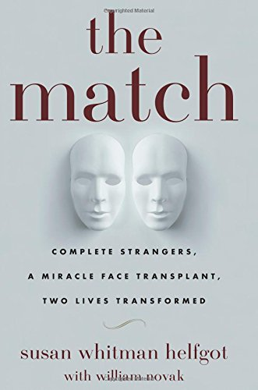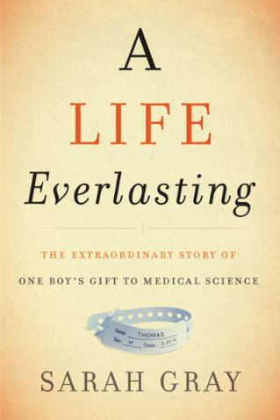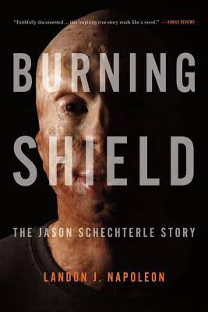

**The Match:** Joseph Helfgot, the son of Holocaust survivors, worked his way from a Lower East Side tenement to create a successful Hollywood research company. But his heart was failing. After months of waiting for a heart transplant, he died during the operation. Hours after his death, his wife Susan was asked a shocking question: would she donate her husband's face to a total stranger? The stranger was James Maki, the adopted son of parents who spent part of World War Ii in an internment camp for Japanese Americans.

**A Life Everlasting:** A donor mother’s powerful memoir of grief and rebirth that is also a fascinating medical science whodunit, taking us inside the world of organ, eye, tissue, and blood donation and cutting-edge scientific research.

**The Burning Shield:** **A gripping biography of Jason Schechterle's battle for life and justice celebrates the resilience of the human spirit. Officer Schechterle’s patrol car was struck by another car traveling in excess of 100 mph. His vehicle burst into flames and he sustained 4th degree burns. This enthralling biography injects the intimacy of fiction into a true story of human endurance. Readers are continuously reminded that Jason Schechterle is flesh, bones, and blood, not a fictional character, and they are invited to experience his terror, frustration, and ultimate triumph." Jason is alive and has vision because of the generosity of donors.**